# Where will the next Waitrose be built?

Kevin Brown

*Disclaimer: Waitrose are unaware of this work. I have no connection with Waitrose or John Lewis.*

## 1.0 Introduction

It is well known that supermarkets choose their locations to fit with their target market – and the location of the supermarket is vital to the success of the shop. The ‘low cost’ supermarkets will target different areas to ‘premium’ supermarkets. But what makes the ideal location for supermarkets? Is it possible to look at where supermarkets are located, understand the neighbourhoods of which they are a part, and then find similar neighbourhoods across the country where they could be placed?

Waitrose is a supermarket in the UK. Compared with other supermarkets, it is perceived to be [more expensive](https://www.telegraph.co.uk/finance/newsbysector/retailandconsumer/10538240/Changing-the-upmarket-perception-of-Waitrose.html), associated with the [more well-off](https://www.theguardian.com/uk/2011/jun/29/waitrose-lidl-shopper-divided-britain) and linked to [Conservative-run councils](https://www.thesun.co.uk/news/3745561/waitrose-shoppers-are-tories-ukippers-prefer-aldi-and-sainsburys-customers-vote-labour-what-does-your-supermarket-choice-on-how-youll-vote-tomorrow/) - and can even [increase house prices](https://www.independent.co.uk/property/house-prices-latest-waitrose-effect-sainsburys-marks-and-spencer-uk-property-a7760926.html), more than other supermarkets.

In this project, I will aim to find the location of all current Waitrose stores and find the characteristics of the area to find which ones are most important, by:

* Finding the name and postcode of all stores
* Finding the lat/lon of all stores
* Finding the political constituency of all stores
* Finding the deprivation index of all stores
* Finding the local amenities for each of the stores
* Exploring if there is any correlation between the data (compared with National data) for Waitrose stores, and trying to find similar areas in the UK where new stores could be built.

In order to predict where the best places are for Waitrose stores to be built I will:

* Filter the list of postcodes by any correlating factors that are found, to potential neighbourhoods of interest
* Looking at the local amenities for those areas, use K-means to determine which of the non-waitrose areas are most closely aligned to the existing waitrose areas, and present some suggested locations.

## 2.0 Data

The data required will come from a variety of sources, and be useful in different ways:

### Store Data

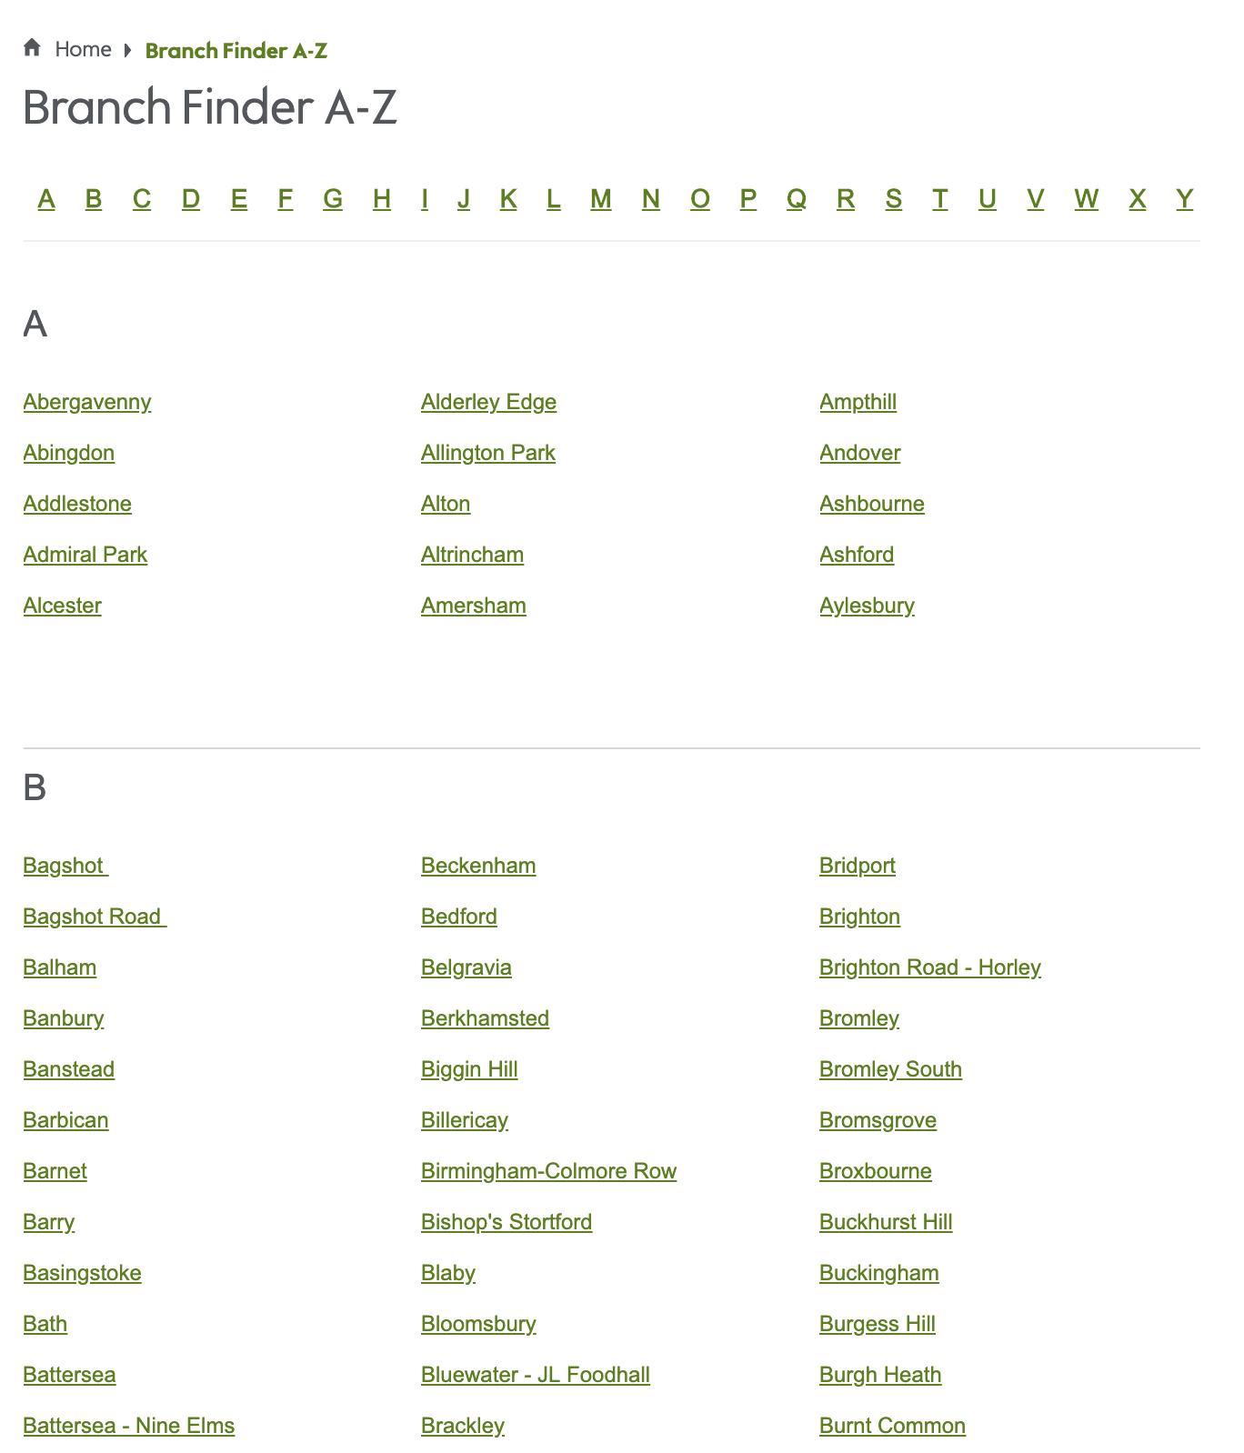Waitrose [A-Z store finder](https://www.waitrose.com/content/waitrose/en/bf_home/branch_finder_a-z.html) has a list of stores, which I can scrape, in order to get the full list of stores, and the URL of that store’s web page.

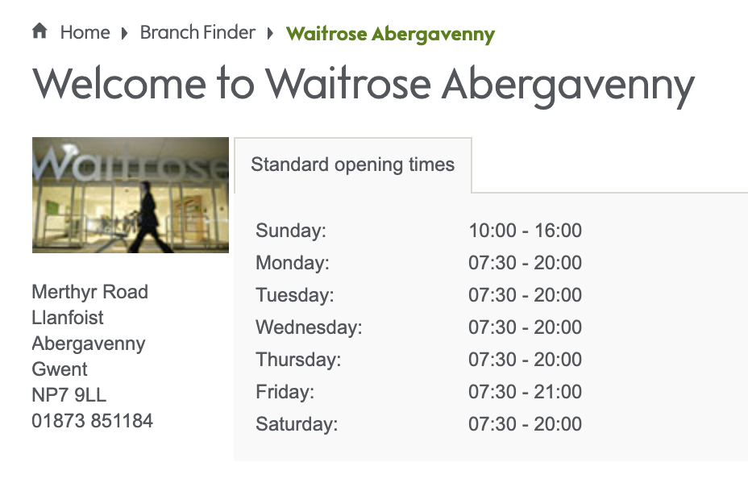Each Waitrose store has its own [web page](https://www.waitrose.com/content/waitrose/en/bf_home/bf/632.html). I’ll need to use the URL to visit the web page for each of the stores, and scrape the postcode and store details.

The features from the A-Z store page will be store name, and URL.

The features required from the store details will primarily be Postcode – but I will capture the Phone number and county, in case it’s needed for display purposes later.

### Postcode Data

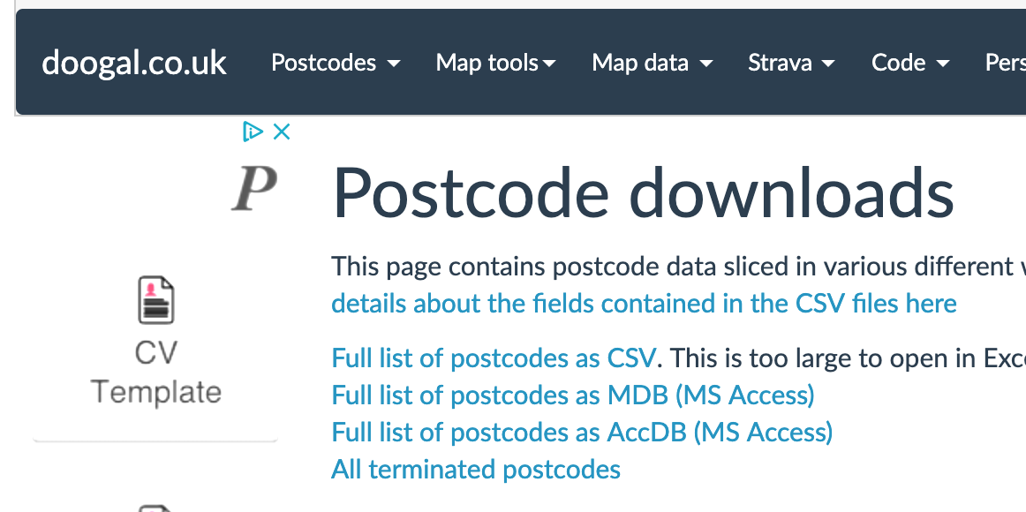There is a python library call postcodes, which I explored for mapping postcodes to Lat/Lon, however it relied on a web service which is no longer active, so the python library does not work.

Therefore, I will use the site doogal.co.uk to download a csv [mapping](https://www.doogal.co.uk/PostcodeDownloads.php) of postcodes to Lat/lon, Parliamentary Constituency, Deprivation index or crime index for that postcode

As described, the features required from the Postcode csv will be looked up using the Postcode of the store, and will consist of the Latitude, Longitude, Constituency ID, Index of Multiple Deprivation. The [field description page](https://www.doogal.co.uk/PostcodeCsvFields.php) describes how the deprivation rank for the postcode, is a number where 1 is the most deprived. The range of values is as follows:

1 - 32844 = England

1 - 1909 = Wales

1 - 6976 = Scotland

1 - 890 = Northern Ireland

### Political Data

Having retrieved the Constituency ID for the postcode, I will need the last election results (2017) to give me the current political party for the constituency under which the Waitrose store currently sits. This is available from the [UK Parliament](https://researchbriefings.parliament.uk/ResearchBriefing/Summary/CBP-7979), as a downloadable csv.

### Neighbourhood / Venue data

From experience, it is usual for Waitrose to be located in towns with lots of local amenities, rather than in a trading estate, or in the countryside etc., Therefore, we’ll review the profile of existing Waitrose stores to see what venues they have around them, and then compare them to some proposed sites, to see which are most similar. The top local amenities around the supermarket, or any UK location are available from Foursquare.

## 3.0 Methodology

The approach to this project was to based on the methodology outlined in the ‘Data Science Methodology’ course on Coursera, and consisted of several stages. The business understanding and data requirements are addressed in the first two sections of this report, and the Evaluation and Feedback sections are covered in sections 4, 5 and 6

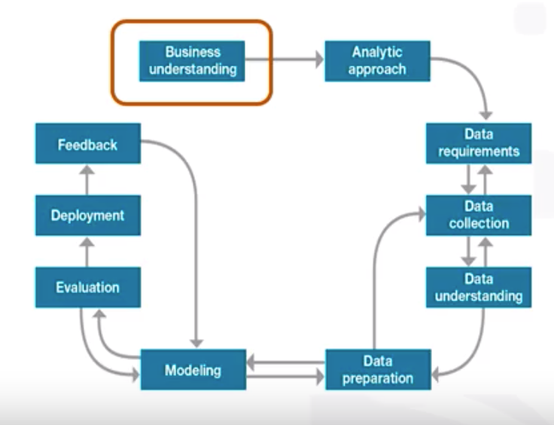

### Analytic Approach

The problem chosen was to predict the location of a new Waitrose Store. In order to to that, we need to understand in more detail the location of existing stores. Therefore, there are two main analytic approaches used:

* Diagnostic (statistical analysis) which will help us understand where Waitrose have already placed their stores, and why they have placed them there.
* Predictive – which will help us to forecast where they might place their stores in the future.

### Data Collection, Understanding and Preparation.

As described by the diagram, data collection, understanding and preparation was done iteratively:

#### Iteration 1 – Store details

In the first part of this iteration, I used BeautifulSoup to extract the Store name from the Waitrose web page. The only other data that was available about the store, was the URL to the store details page. At the end of this stage, my dataframe consisted of Store name and URL.

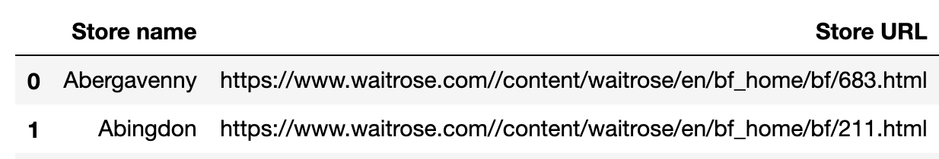

Data cleaning needed to be done. Some Store URLs were absolute, and some relative – so the domain needed to be added. In addition some URLs started /content/waitrose/en/bf_home – and some started /bf_home. This did not matter however as both worked OK as URLs.

I then used the URL obtained in the first iteration to scrape the Store page, to pull back the Postcode, phone number and county. At this point I found that the Peterborough store, which was on the A-Z list, had been closed, so I removed this from my list. At the end of this stage, I had a dataframe with the extra fields, which, to save lots of web-scraping in future, I saved into its own csv file:

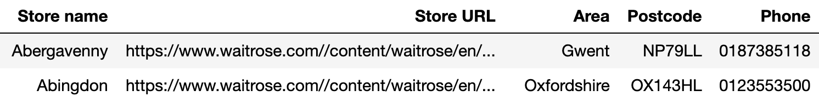

#### Iteration 2 – Lat/Lon

In this iteration, I needed to use the Postcode, to get Lat/Lon for each store and add columns to dataframe. I loaded the csv of Postcodes into a dataframe, and reviewed the columns. I considered if “Distance to train station”, “Police Force name”, “Ward name” etc. would be useful. The only features selected for use were Latitude, Longitude, Constituency and Index of Multiple Deprivation (see Section 2 for details). Very little data cleaning was required to join the postcode dataset with the Store data set:

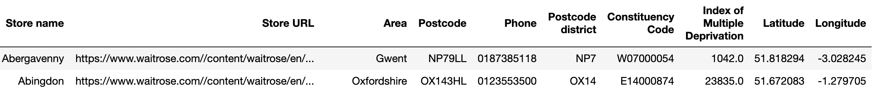

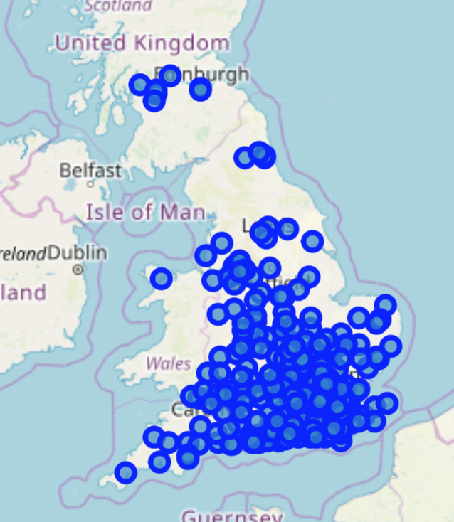To help understand the data, I plotted the 350 locations of the stores on a map. This shows that there are very few Wales, Scotland or Northern Ireland.

On zooming in more closely to my local area, I can confirm the stores are where they should be.

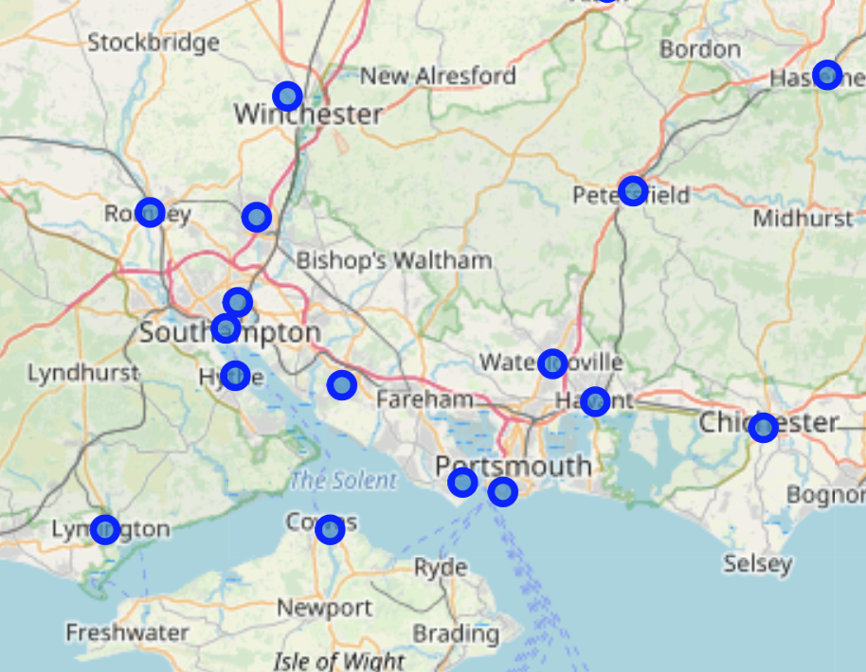

#### Iteration 3 – Political Data

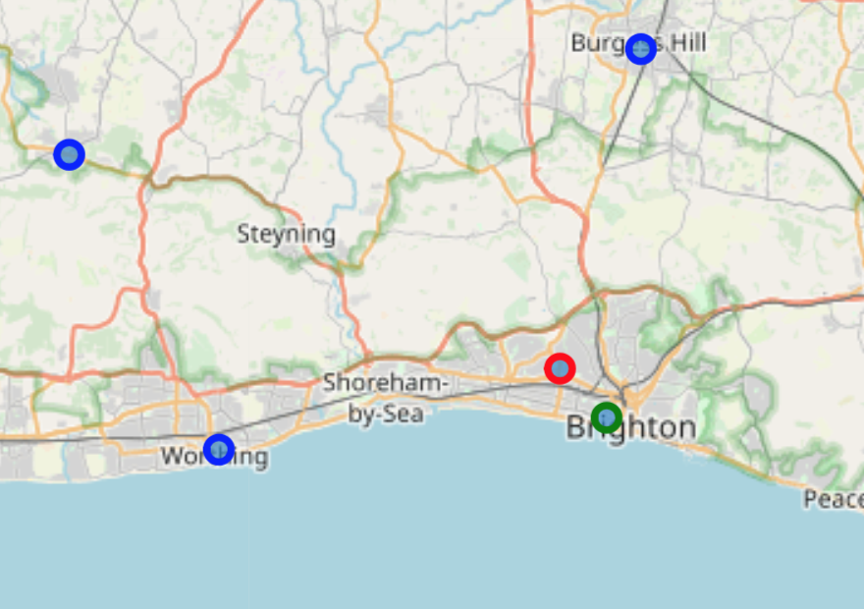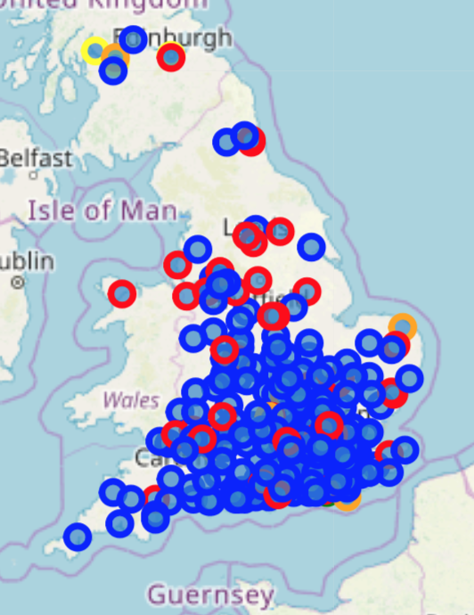While the map above is useful, it doesn’t tell us much about the stores. This iteration pulls in data from UK Parliament about the party represented in each constituency. Again the dataset was pretty complete, so no real data cleansing issues to merge this with the store data. We could then understand the data a bit more by showing the stores where the colour represented the politics of the area.

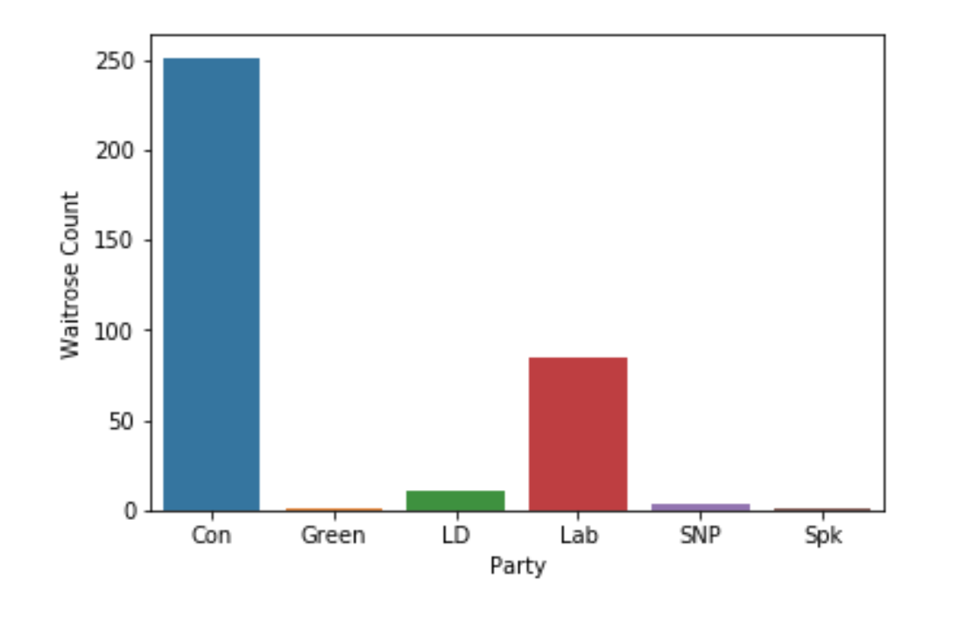

The predominant colour on the map is blue (Conservative). The chart confirms this in numbers, showing that there are far more stores in Conservative areas than other areas. However, this does not confirm a bias toward Conservative areas, because it may be that there are just more Conservative areas across the country.

#### Iteration 4 – Political Data for the Country

We therefore need to obtain the political results for the whole country, and determine whether these results are in proportion, or if there is a bias. Once the raw numbers were obtained, the percentage of total neighborhoods (and percentage of total stores) was calculated so that the data could be compared. For this project, I used Seaborn charting library. This requires use of the pandas melt function to convert the dataframe from short format (left) to long format (middle).

From the chart, it can be seen that there is definitely a skew towards conservative-held areas.

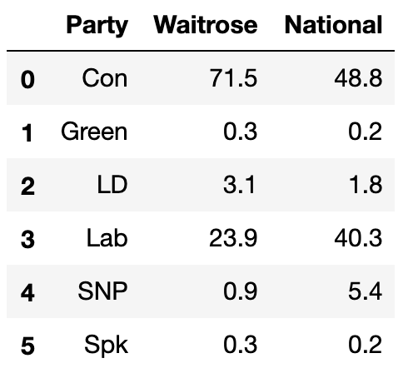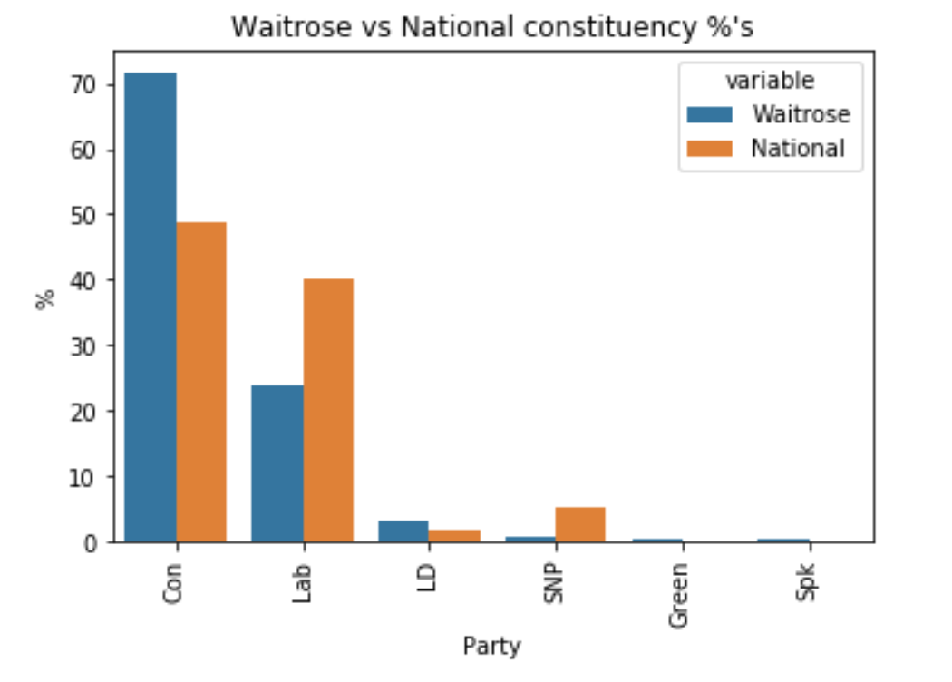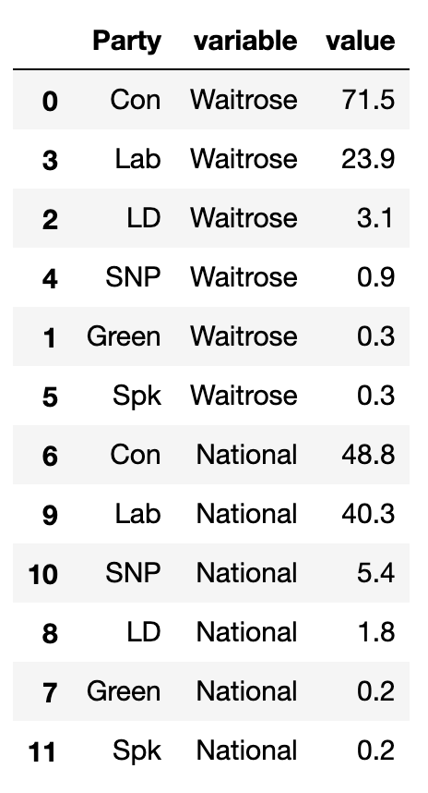

#### Iteration 5 – Deprivation Index

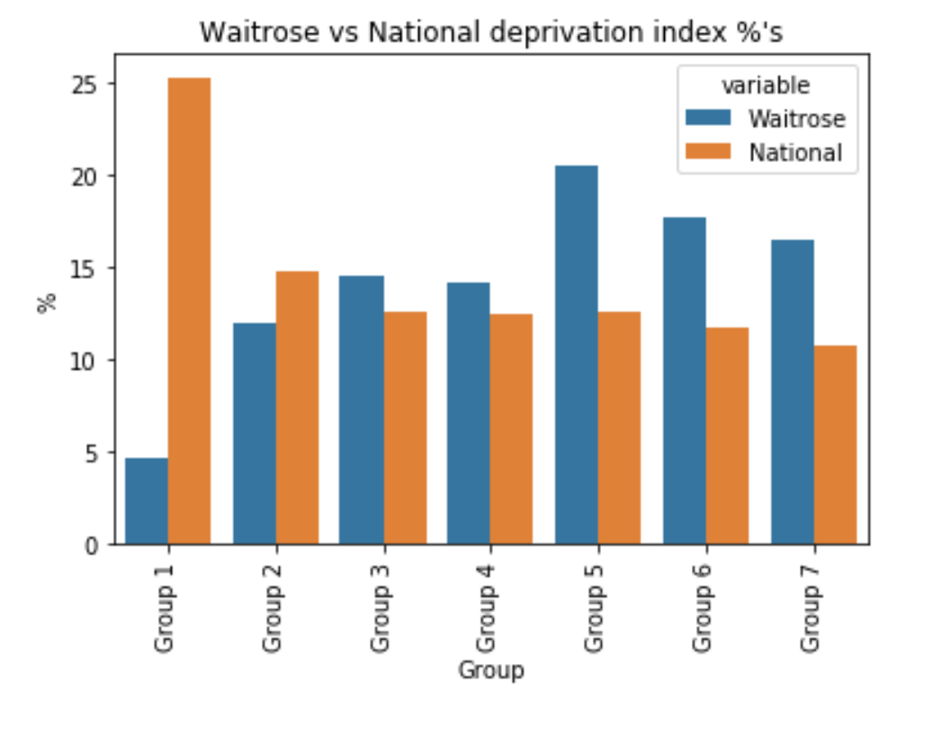The deprivation rank is given for each postcode, where 1 is the most deprived, and the least deprived is 32844 (in England).

I again wanted to compare the locations for Waitrose stores with the national picture. I therefore binned the deprivation index into 7 groups, with Group 1 being most deprived.

I then repeated the charting methodology above – the resulting chart shows the percentage of stores per deprivation group (blue), and the percentage of postcodes per deprivation group (orange).

From this chart, we can see that there are far fewer stores in the most deprived areas (Group 1) and proportionally more stores in Groups 5, 6 and 7. From this we can conclude there is a bias (intended or not) towards placing Waitrose in the least deprived areas.

### Modelling

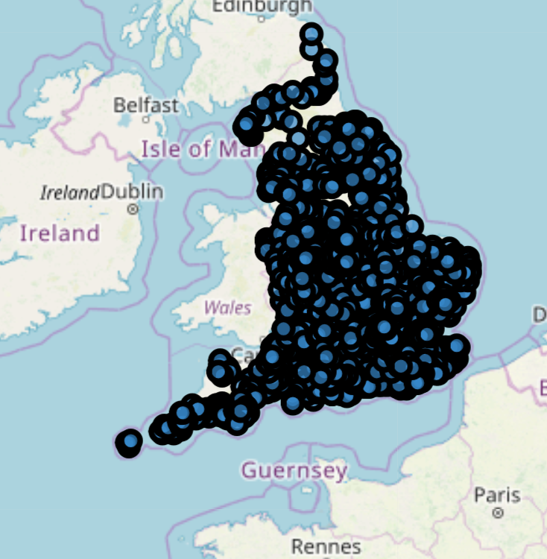At this point, we make our first entry into Modelling, though we return to data collection soon, then back to modelling later. We now understand enough about the Waitrose stores, to suggest a broad set of initial locations for new stores: Those postcodes which have a conservative constituent, and those which have a deprivation index that fits into Group 5, 6 or 7.

I also decided that predicting per postcode was too specific (given there is usually one or two postcodes per road, and added the postal district (often an area of 1 or 2 square km), from the postcodes CSV, into our store data.

This analytical based modelling gives us our first representation of potential sites- but even with postal districts, there are almost 1200 of these locations, so we need to collect more data about the area, and use these features in order to better predict locations.

### Data Collection, Understanding and Preparation.

#### Iteration 6 – Foursquare data for proposed sites

This iteration involved using the Foursquare API, for each lat / lon of our proposed sites, to collect information about the facilities (or ‘venues’) in each area - before then clustering these and fitting the Waitrose stores into the clusters. The cluster where most Waitrose stores fit (ie most similar to existing neighborhoods which contain Waitrose) is where we should look to build new stores.

To start, we collected the data from Foursquare. After the API failed to respond once or twice towards the end of my 1200 requests, I resorted to collecting small batches of data, and appending them together to form a dataframe, which I saved as a CSV, to avoid the same difficulties again later:

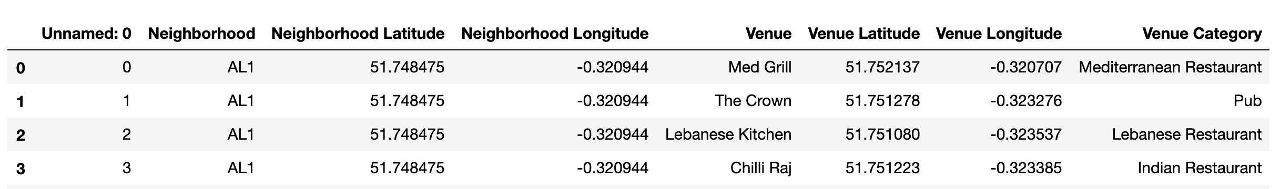

The dataframe was grouped by Neighbourhood and most common venues varied widely, as expected from a (reasonably) diverse set of locations.

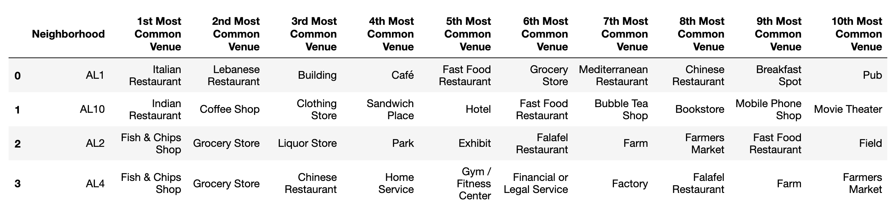

One-hot encoding was then used to turn the data into numbers so it could be used by the K-mean clustering algorithm.

### Modelling

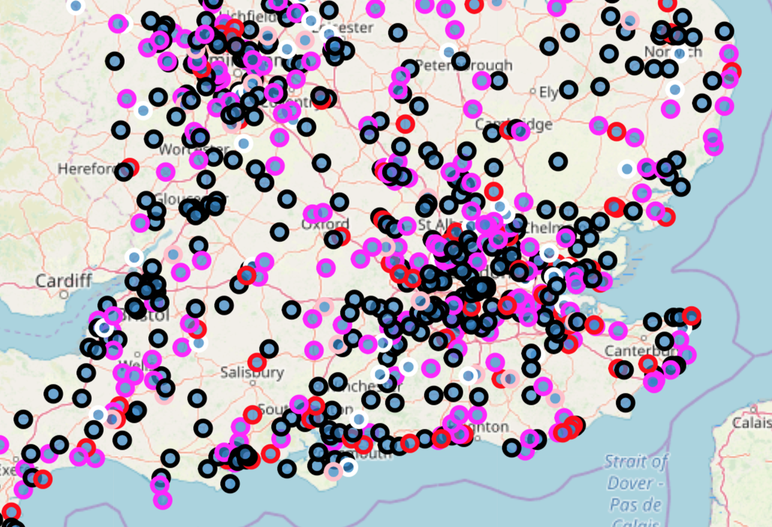The K-means clustering was applied to split the data into 5 clusters, which were then plotted on the map. Each cluster had different, sets of venues to each other, but, looking at the data, they were similar within group. (See next page)

It was interesting to hypothesize which of the clusters our existing Waitrose stores would fall in. Would they fall across a wide spectrum, or fall into one category?

#### Proposed site clusters

Cluster 0 – Convenience stores and food?

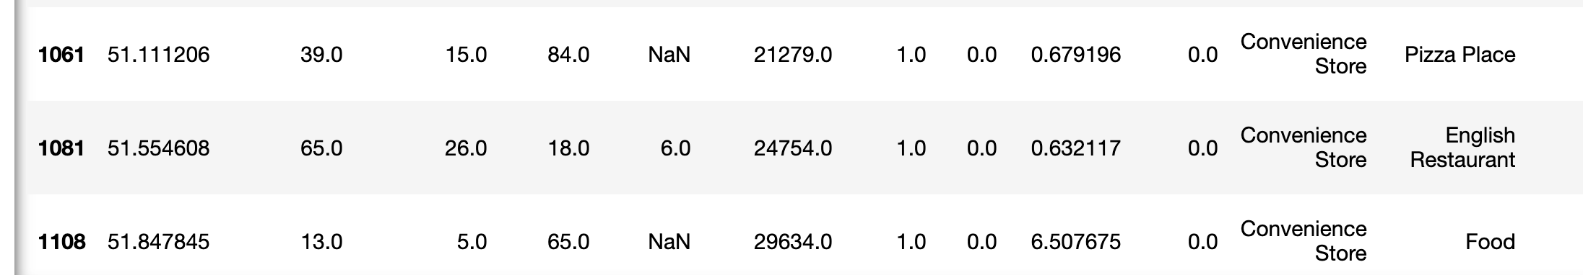

Cluster 1 – Health and Leisure?

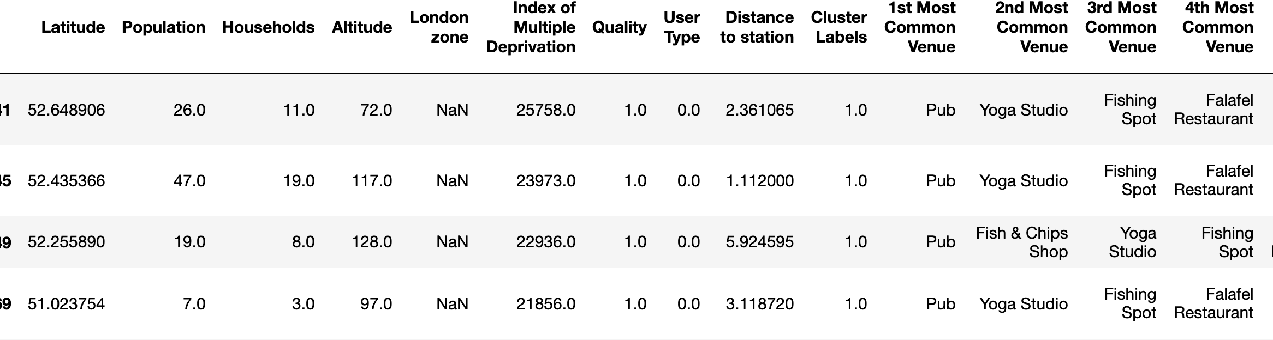

Cluster 2 – Outdoor venues and groceries?

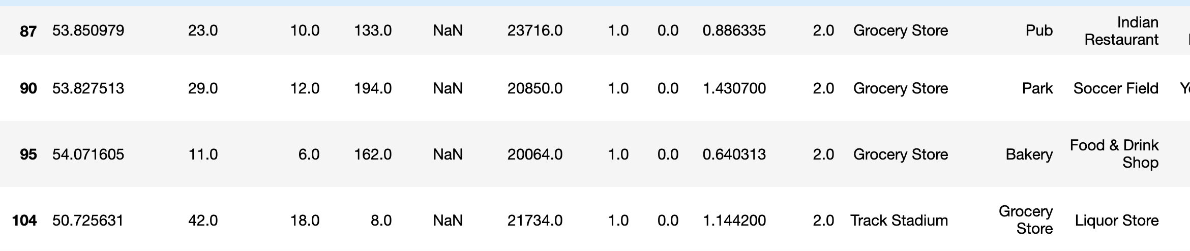

Cluster 3 – Services? Miscellaneous?

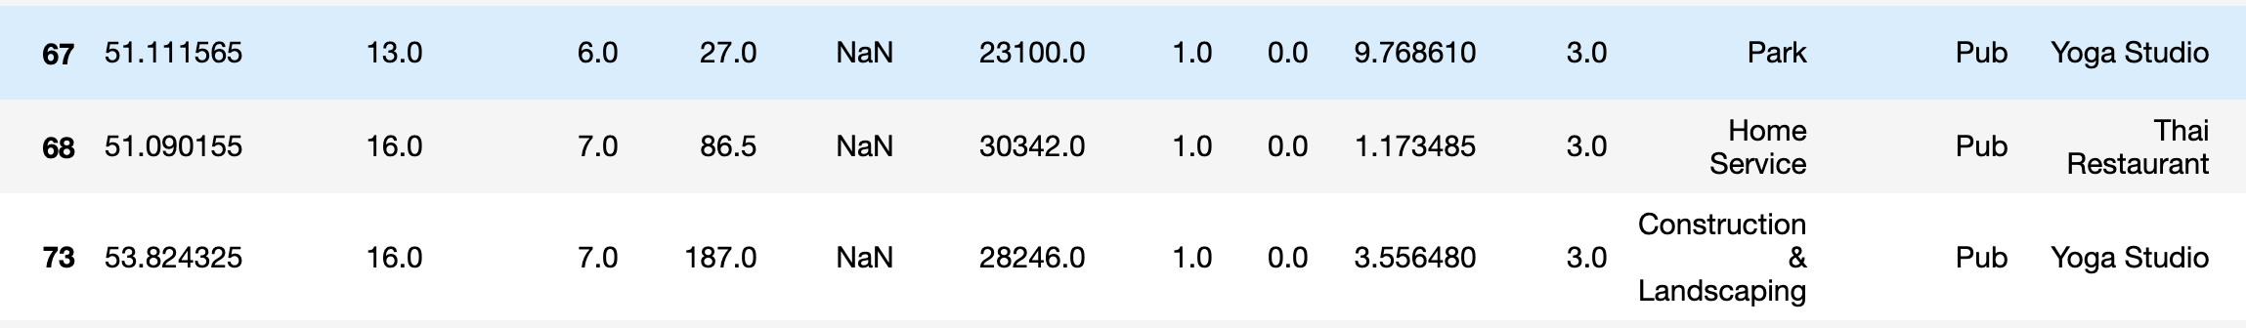

Cluster 4 – Restaurants, coffee shops and pubs/bars

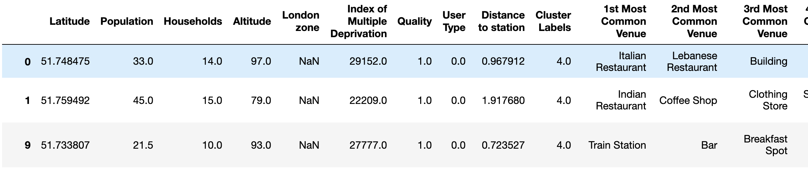

### Data Collection, Understanding and Preparation.

#### Iteration 7 – Foursquare data for Waitrose sites

### As with the proposed sites, we used the Foursquare API, for each lat / lon of our proposed sites, to collect all the data about venues around the Waitrose sites

### Looking at the data, it’s clear to see the kinds of venues that Waitrose like to have nearby – Pubs, Coffee Shops, restaurants:

### 

### We one-hot encoded the Waitrose venue data in preparation for running kmeans.predict() against the model prepared with our proposed site data.

Some features (venues) obtained with this Waitrose location data set were not in the proposed site data set – and some in the proposed site data set were not in the Waitrose dataset. In order to use our K-means model to predict, these needed to be the same.

Therefore, we added features to the Waitrose location data that were not present, by setting these to 0, and removed some features that were extra. We were now able to fit the data to the model, and view the cluster that each site fitted into.

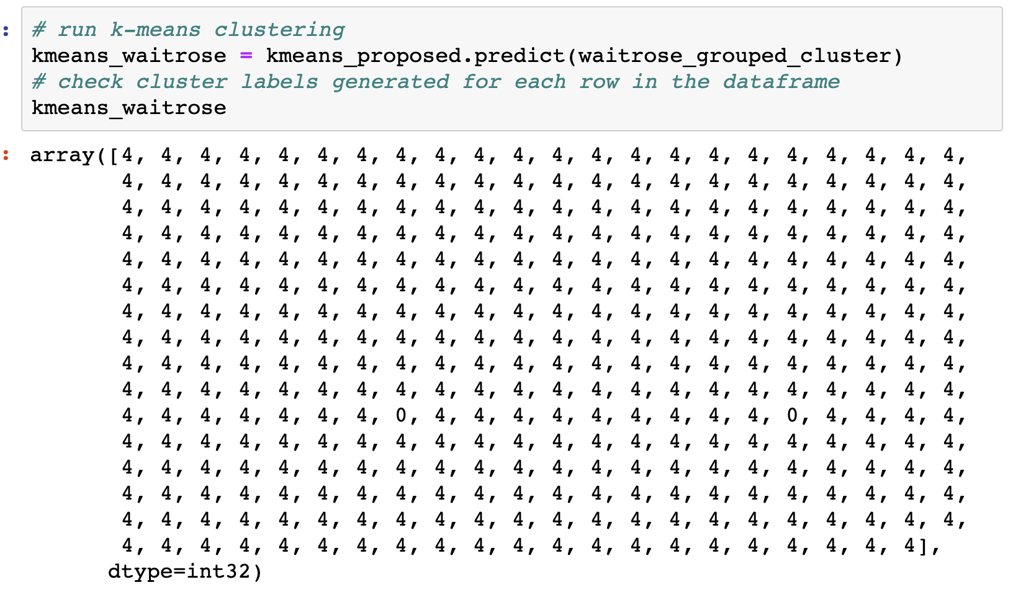Most of the data fitted into Cluster 4 (Restaurants, coffee shops and pubs / bars), with some fitting to Cluster 0 (Convenience stores / food). This was a surprising result initially, but looking at the expected venues above, this closely matches the description we gave to cluster 4.

Given this result, we were able to remove clusters 0-3 from the proposed site data set, and focus on cluster 4.

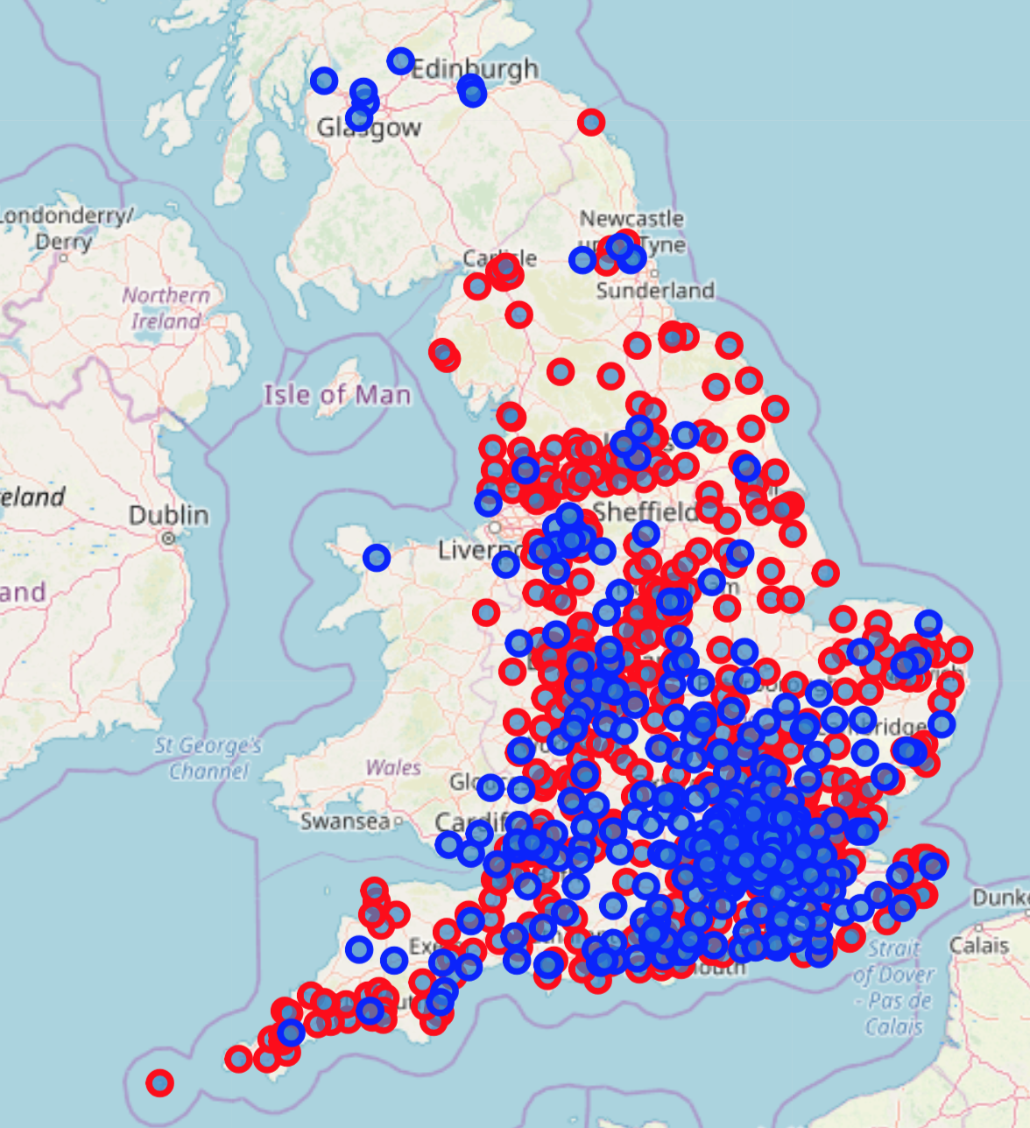

I plotted the existing stores (blue), with our new refined set of predicted sites, and zoomed into my local area to see what it suggested.

## 4.0 Results

* Waitrose has around 350 stores across the UK, but does not feature strongly in Wales, Scotland or Northern Ireland.
* Waitrose is a higher end supermarket
* There is a bias towards Conservative run areas
* There is a bias towards areas which are least deprived
* Waitrose are often found near pubs, coffee shops and restaurants.
* 500 similar neighbourhoods have been identified to those with Waitrose stores, and mapped, providing seemingly sensible locations for new Waitrose Stores
* There could be a lot more done to refine the model further (see Extensions)

### Store Data

Waitrose

## 5.0 Discussion

* There would be a lot more that could be done to refine and check the model.
  + Using more data - correlating with crime statistics and other neighbourhood features
  + Taking into account the results of each store (with access to confidential data) so only the best stores could be modelled
  + Taking into account the delivery depots, supply chains, proximity to other stores, size of stores etc., to make the results more compelling.
* There could be more analysis (variance, correlations, p-Value etc) to help validate results. However for this project the bar charts and histograms were reasonably compelling.

### Store Data

Waitrose

## 6.0 Conclusion

* There would be a lot more that could be done to refine and check the model.
  + Using more data - correlating with crime statistics and other neighbourhood features
  + Taking into account the results of each store (with access to confidential data) so only the best stores could be modelled
  + Taking into account the delivery depots, supply chains, proximity to other stores, size of stores etc., to make the results more compelling.
* There could be more analysis (variance, correlations, p-Value etc) to help validate results. However for this project the bar charts and histograms were reasonably compelling.

### Store Data

Waitrose